3D Filament Swatch
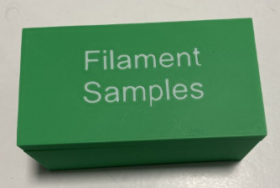 | 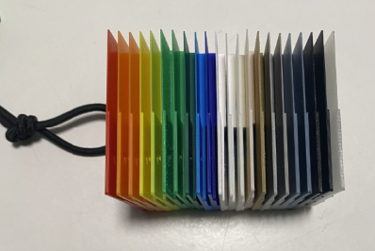

Project Goal
Create a collection of swatches printed with different filaments.
After a few test and experiment, I decided that the best compromise is for each tile is:
- Dimension: 50x49,60 mm
- Thickness: 3 mm

All tiles are kept together using an elastic rope.
All tiles should have a box.
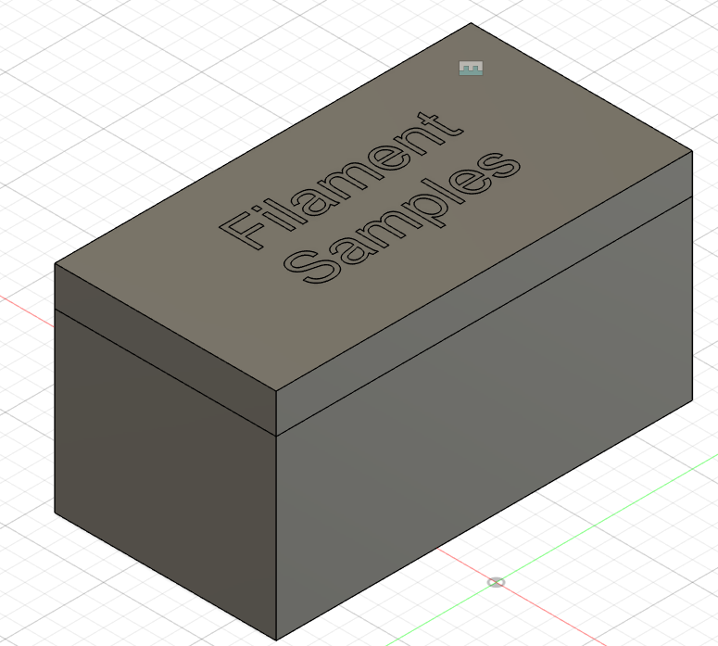

All tiles have different regions with different thickness so I can evaluate the transparency and rigidity of the material, from 0.4 to 1, then 2, and finally 3 mm.

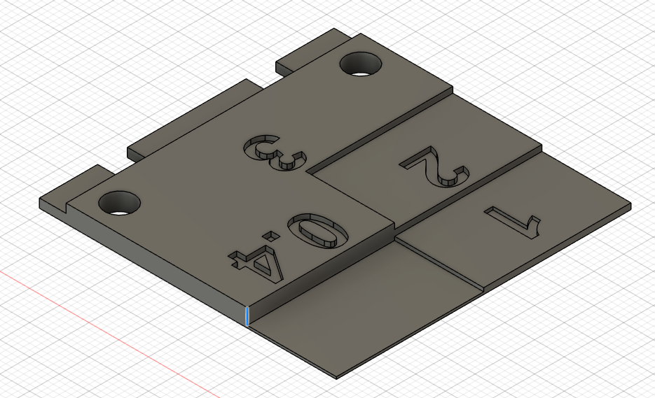

On the back there should be a clear indicator of the material, the producer and the ordering information.

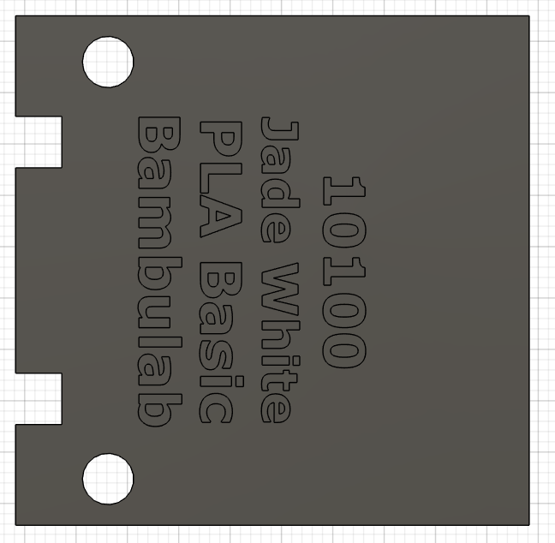

Cord selection
I have tested:
- 4 mm elastic cord: this is too big
- 3 mm elastic cord – This is the chosen one

Cord link on Amazon
https://amzn.eu/d/47qVaVn

